Strict mode in JavaScript
The “use strict” directive, introduced in ECMAScript version 5, is a literal expression rather than a statement and is ignored by earlier JavaScript versions. Its purpose is to enforce strict mode, ensuring the code is executed with stricter parsing and error handling. In strict mode, you cannot use undeclared variables, among other enforced rules. Using “use strict”; eliminates silent errors, enhances performance, disables unsafe features, and makes code more secure and easier to debug.
The benefits of Using strict
Strict mode makes several changes to normal JavaScript semantics.
- Eliminates Silent Errors: Converts JavaScript silent errors into throw errors, making debugging easier.
- Optimization: Helps JavaScript engines perform optimizations, potentially making strict mode code run faster than non-strict code.
- Future-Proofing: Prohibits syntax likely to be defined in future ECMAScript versions.
- Prevents Unsafe Actions: Throws errors when relatively “unsafe” actions are taken, such as accessing the global object.
- Disables Confusing Features: Disables features that are confusing or poorly designed.
- Security: Makes it easier to write “secure” JavaScript
How to Use Strict Mode
Strict mode can be used in two ways, remember strict mode doesn’t work with block statements enclosed in {} braces.
- Global Scope: Applies to the entire script.
- Function Scope: Applies to individual functions.
Using Strict Mode for the Entire Script
To invoke strict mode for an entire script, put the exact statement “use strict”; (or ‘use strict’;) before any other statements.
// Whole-script strict mode syntax
'use strict';
let v = "strict mode script!";
Enable strict mode on a function-by-function basis to avoid issues when concatenating strict and non-strict scripts, ensuring compatibility and preventing unintended strict mode application in the entire script.
Using Strict Mode for a Function
Likewise, to invoke strict mode for a function, put the exact statement “use strict”; (or ‘use strict’;) in the function’s body before any other statements.

function strict() {

// Function-level strict mode syntax
'use strict';

function nested() { return 'Javascript Basics to Advance‘; }

return "strict mode function! " + nested();
}
function notStrict() { return "non strict function"; }

Examples of using Strict mode
Example: Mistyping a Variable Name
In strict mode, assigning a value (3.14) to an undeclared variable (x) without prior declaration throws an error.
JavaScript
// Using a variable, without declaring it, is not allowed:
'use strict';
x = 3.14; //will throw an error because no ‘let’ keyword
Output:
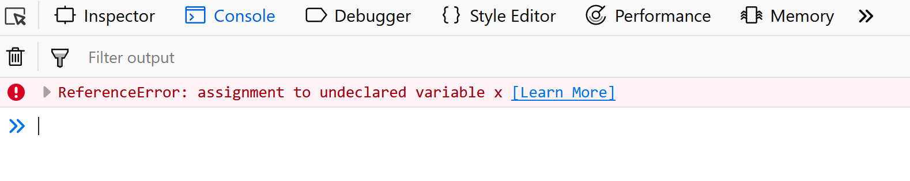
Example: Using a Variable Without Declaring It
In strict mode, assigning a value to an undeclared variable (x) as an object ({p1:10, p2:20}) without prior declaration throws an error.
JavaScript
// Objects are variables too.
// Using an object, without declaring it, is not allowed:
'use strict';

// Will throw an error
x = { p1: 10, p2: 20 };
Output:

Example: Deleting a Variable or Object
In strict mode, attempting to delete a variable (delete x;) or function (delete x; where x is a function) declaration throws an error.
JavaScript
'use strict';
let x = 3.14;

// Deleting a function is also not allowed
'use strict';
function x(p1, p2) {};

// Will throw an error
delete x;
Output:
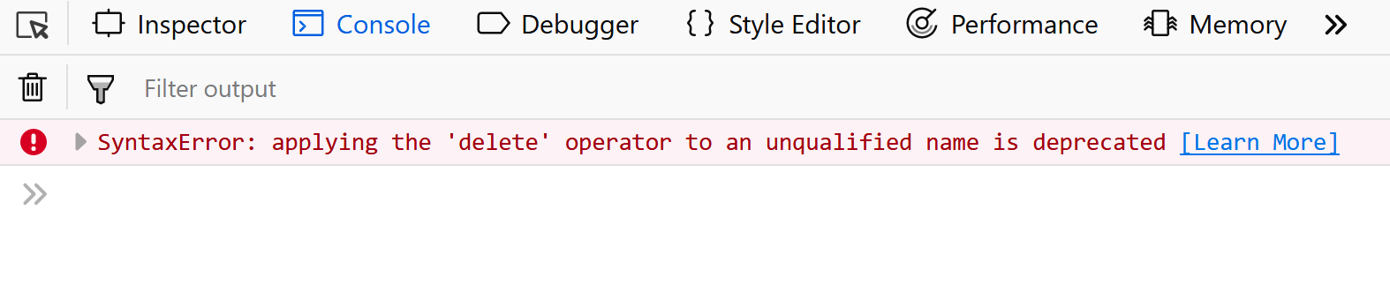
Example: Duplicating a Parameter Name
Using ‘use strict’;, defining a function with duplicate parameter names (p1, p1) causes an error due to parameter name duplication being disallowed in strict mode functions
JavaScript
'use strict';

// Will throw an error because p1 and p1 repeated
function x(p1, p1) {};
Output:
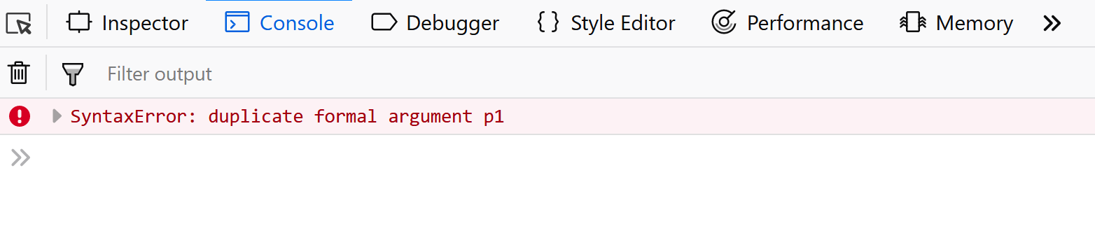

JavaScript Hoisting
Last Updated : 09 Oct, 2024

JavaScript Hoisting is the behavior where the interpreter moves function and variable declarations to the top of their respective scope before executing the code. This allows variables to be accessed before declaration, aiding in more flexible coding practices and avoiding “undefined” errors during execution.
What is Hoisting in JavaScript?
Hoisting is the default behavior in JavaScript where variable and function declarations are moved to the top of their respective scopes during the compilation phase. This guarantees that regardless of where these declarations appear within a scope, they can be accessed throughout that scope.
Features of Hoisting
- Declarations are hoisted, not initializations.
- Allows calling functions before their declarations.
- All variable and function declarations are processed before any code execution.
- Undeclared variables are implicitly created as global variables when assigned a value.
Note: JavaScript only hoists declarations, not initializations.
JavaScript allocates memory for all variables and functions defined in the program before execution.
Sequence of variable declaration
The following is the sequence in which variable declaration and initialization occur.
Declaration –> Initialisation/Assignment –> Usage
Variable lifecycle
let a; // Declaration
a = 100; // Assignment
console.log(a); // Usage
However, since JavaScript allows us to both declare and initialize our variables simultaneously, so we can declare and initialize at the same time.
let a = 100;
Note: Always remember that in the background the Javascript is first declaring the variable and then initializing them. It is also good to know that variable declarations are processed before any code is executed.
However, in javascript, undeclared variables do not exist until the code assigning them is executed. Therefore, assigning a value to an undeclared variable implicitly creates it as a global variable when the assignment is executed. This means that all undeclared variables are global variables.
Different Examples of JavaScript Hoisting
1. Global Scope
JavaScript
// Hoisting
function codeHoist() {
a = 10;
let b = 50; // inside so can not be used outside funct
}
codeHoist();

console.log(a); // 10
console.log(b); // ReferenceError : b is not defined
Output:
10
ReferenceError: b is not defined
Explanation: In the above example, hoisting allows variables declared with var to be accessed before declaration, but not those declared with let or const. Thus, a is accessible, but b throws a ReferenceError
Note: There’s a difference between ReferenceError and undefined errors. An undefined error occurs when we have a variable that is either not defined or explicitly defined as type undefined.
ReferenceError is thrown when trying to access a previously undeclared variable.

